**Thủ tục**

**Bài 1:**

**Code:**

create procedure tt_B1 @masach nvarchar(10), @soluongban int output

as

begin

select @soluongban = SUM(tChiTietHDB.SLBan)

from tChiTietHDB, tHoaDonBan

where tChiTietHDB.SoHDB = tHoaDonBan.SoHDB and YEAR(tHoaDonBan.NgayBan) = 2014 and tChiTietHDB.MaSach = @masach

end;

declare @slb int;

exec tt_B1 'S01', @slb output;

print @slb;

drop procedure tt_B1;

**Kết quả:**



**Bài 2:**

**Code:**

create procedure tt_B2 @ngay date, @soluonghd int output, @soluongtienban float output

as

begin

select @soluonghd = COUNT(SoHDB)

from tHoaDonBan

where CAST(tHoaDonBan.NgayBan as DATE) = @ngay;

select @soluongtienban = SUM(tSach.DonGiaBan * tChiTietHDB.SLBan)

from tSach, tChiTietHDB, tHoaDonBan

where CAST(tHoaDonBan.NgayBan as DATE) = @ngay and tChiTietHDB.SoHDB = tHoaDonBan.SoHDB and tChiTietHDB.MaSach = tSach.MaSach;

end;

declare @slhd int, @sltb float;

exec tt_B2 '2014-08-11', @slhd output, @sltb output;

print @slhd;

print @sltb;

drop procedure tt_B2;

**Kết quả:**

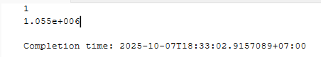

**Bài 3:**

**Code:**

create procedure tt_B3 @mancc nvarchar(255), @somasach int output, @sotien float output

as

begin

select @somasach = COUNT(tChiTietHDN.MaSach)

from tHoaDonNhap, tChiTietHDN

where tHoaDonNhap.MaNCC = @mancc and tHoaDonNhap.SoHDN = tChiTietHDN.SoHDN;

select @sotien = SUM(tSach.DonGiaNhap * tChiTietHDN.SLNhap)

from tSach, tChiTietHDN, tHoaDonNhap

where tHoaDonNhap.MaNCC = @mancc and tHoaDonNhap.SoHDN = tChiTietHDN.SoHDN and tChiTietHDN.MaSach = tSach.MaSach;

end;

declare @sms int, @st float;

exec tt_B3 'NCC01', @sms output, @st output;

print @sms;

print @st;

drop procedure tt_B3;

**Kết quả:**

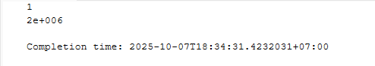

**Bài 4:**

**Code:**

create procedure tt_B4 @nam int, @sotiennhaphang float output, @sotienbanhang float output

as

begin

select @sotiennhaphang = SUM(tSach.DonGiaNhap * tChiTietHDN.SLNhap)

from tSach, tChiTietHDN, tHoaDonNhap

where YEAR(tHoaDonNhap.NgayNhap) = @nam and tHoaDonNhap.SoHDN = tChiTietHDN.SoHDN and tChiTietHDN.MaSach = tSach.MaSach;

select @sotienbanhang = SUM(tSach.DonGiaBan * tChiTietHDB.SLBan)

from tSach, tChiTietHDB, tHoaDonBan

where YEAR(tHoaDonBan.NgayBan) = @nam and tChiTietHDB.SoHDB = tHoaDonBan.SoHDB and tChiTietHDB.MaSach = tSach.MaSach;

end;

declare @stnh float, @stbh float;

exec tt_B4 '2014', @stnh output, @stbh output;

print @stnh;

print @stbh;

drop procedure tt_B4;

**Kết quả:**

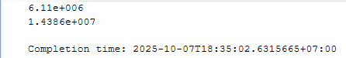

**Bài 5:**

**Code:**

create procedure tt_B5 @manxb nvarchar(255), @soluongton int output

as

begin

select @soluongton = SUM(tSach.SoLuong)

from tSach

where tSach.MaNXB = @manxb;

end;

declare @mnxb nvarchar(255);

exec tt_B5 'NXB01', @mnxb output;

print @mnxb;

drop procedure tt_B5;

**Kết quả:**

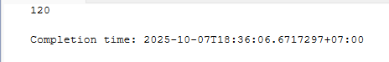

**Bài 6:**

**Code:**

create procedure tt_B6 @sohdn nvarchar(255), @manv nvarchar(255), @ngaynhap datetime, @mancc nvarchar(255), @masach nvarchar(255), @slnhap int

as

begin

begin TRAN

begin TRY

insert into tHoaDonNhap

values (@sohdn, @manv, @ngaynhap, @mancc);

insert into tChiTietHDN

values (@sohdn, @masach, @slnhap, NULL);

commit TRAN;

end TRY

begin CATCH

print 'Error: ' + ERROR_MESSAGE();

rollback TRAN;

end CATCH

end;

exec tt_B6 'HDN100', 'NV01', '2014-08-11 00:00:00.000', 'NCC01', 'S01', 100;

select * from tChiTietHDN where SoHDN = 'HDN100';

select * from tHoaDonNhap where SoHDN = 'HDN100';

drop procedure tt_B6;

**Kết quả:**

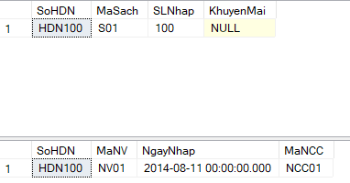

**Bài 7:**

**Code:**

create procedure tt_B7 @sohdb nvarchar(255)

as

begin

begin TRAN

begin TRY

delete from tHoaDonBan

where SoHDB = @sohdb;

delete from tChiTietHDB

where SoHDB = @sohdb;

commit TRAN;

end TRY

begin CATCH

print 'Error: ' + ERROR_MESSAGE();

rollback TRAN;

end CATCH

end;

exec tt_B7 'HDB100';

select * from tHoaDonBan where SoHDB = 'HDB100';

select * from tChiTietHDB where SoHDB = 'HDB100';

drop procedure tt_B7;

**Kết quả:**

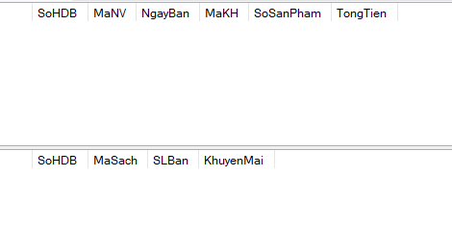

**Bài 8:**

**Code:**

create procedure tt_B8 @nam int, @soluongsachnhap int output, @soluongsachban int output

as

begin

select @soluongsachnhap = SUM(tChiTietHDN.SLNhap)

from tChiTietHDN, tHoaDonNhap

where YEAR(tHoaDonNhap.NgayNhap) = @nam and tHoaDonNhap.SoHDN = tChiTietHDN.SoHDN;

select @soluongsachban = SUM(tChiTietHDB.SLBan)

from tChiTietHDB, tHoaDonBan

where YEAR(tHoaDonBan.NgayBan) = @nam and tHoaDonBan.SoHDB = tChiTietHDB.SoHDB;

end;

declare @slsn int, @slsb int;

exec tt_B8 2014, @slsn output, @slsb output;

print @slsn;

print @slsb;

drop procedure tt_B8;

**Kết quả:**

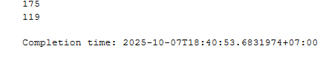

**Bài 9:**

**Code:**

create procedure tt_B9 @masach nvarchar(255), @nam int, @soluongsachnhap int output, @soluongsachban int output

as

begin

select @soluongsachnhap = SUM(tChiTietHDN.SLNhap)

from tChiTietHDN, tHoaDonNhap

where YEAR(tHoaDonNhap.NgayNhap) = @nam and tHoaDonNhap.SoHDN = tChiTietHDN.SoHDN and tChiTietHDN.MaSach = @masach;

select @soluongsachban = SUM(tChiTietHDB.SLBan)

from tChiTietHDB, tHoaDonBan

where YEAR(tHoaDonBan.NgayBan) = @nam and tHoaDonBan.SoHDB = tChiTietHDB.SoHDB and tChiTietHDB.MaSach = @masach;

end;

declare @slsn int, @slsb int;

exec tt_B9 'S01', 2014, @slsn output, @slsb output;

print @slsn;

print @slsb;

drop procedure tt_B9;

**Kết quả:**

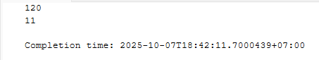

**Bài 10:**

**Code:**

create procedure tt_B10 @makh nvarchar(255), @nam int, @soluongsachmua int output, @soluongtientieu float output

as

begin

select @soluongsachmua = SUM(tChiTietHDB.SLBan)

from tChiTietHDB, tHoaDonBan

where YEAR(tHoaDonBan.NgayBan) = @nam and tHoaDonBan.MaKH = @makh and tHoaDonBan.SoHDB = tChiTietHDB.SoHDB;

select @soluongtientieu = SUM(tChiTietHDB.SLBan * tSach.DonGiaBan)

from tChiTietHDB, tHoaDonBan, tSach

where YEAR(tHoaDonBan.NgayBan) = @nam and tHoaDonBan.MaKH = @makh and tHoaDonBan.SoHDB = tChiTietHDB.SoHDB and tSach.MaSach = tChiTietHDB.MaSach;

end;

declare @slsm int, @sltt float;

exec tt_B10 'KH01', 2014, @slsm output, @sltt output;

print @slsm;

print @sltt;

drop procedure tt_B10;

**Kết quả:**

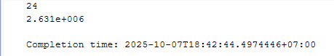

**Bài 11:**

**Code:**

create procedure tt_B11 @makh nvarchar(255), @nam int, @soluonghoadon int output, @soluongtientieu float output

as

begin

select @soluonghoadon = COUNT(tHoaDonBan.SoHDB)

from tHoaDonBan

where YEAR(tHoaDonBan.NgayBan) = @nam and tHoaDonBan.MaKH = @makh;

select @soluongtientieu = SUM(tChiTietHDB.SLBan * tSach.DonGiaBan)

from tChiTietHDB, tHoaDonBan, tSach

where YEAR(tHoaDonBan.NgayBan) = @nam and tHoaDonBan.MaKH = @makh and tHoaDonBan.SoHDB = tChiTietHDB.SoHDB and tSach.MaSach = tChiTietHDB.MaSach;

end;

declare @slhd int, @sltt float;

exec tt_B11 'KH01', 2014, @slhd output, @sltt output;

print @slhd;

print @sltt;

drop procedure tt_B11;

**Kết quả:**

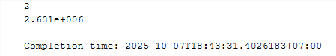

**Hàm**

**Bài 1:**

**Code:**

create function h_B1 (@nam int)

returns float

as

begin

declare @tongsotien float;

select @tongsotien = SUM(tSach.DonGiaNhap * tChiTietHDN.SLNhap)

from tSach

join tChiTietHDN

on tSach.MaSach = tChiTietHDN.MaSach

join tHoaDonNhap

on tChiTietHDN.SoHDN = tHoaDonNhap.SoHDN

where YEAR(tHoaDonNhap.NgayNhap) = @nam

return @tongsotien;

end;

declare @returnVal float;

set @returnVal = dbo.h_B1(2014);

print @returnVal;

drop function h_B1;

**Kết quả:**

**Bài 2:**

**Code:**

create function h_B2(@thang int)

returns table

as

return (

select top 5 tSach.*

from tSach

join(

select tChiTietHDB.MaSach, SUM(tChiTietHDB.SLBan) as SoLuongSachBan

from tChiTietHDB

join tHoaDonBan

on tChiTietHDB.SoHDB = tHoaDonBan.SoHDB

where MONTH(tHoaDonBan.NgayBan) = @thang

group by tChiTietHDB.MaSach

) as DsBan

on tSach.MaSach = DsBan.MaSach

order by SoLuongSachBan

);

select * from h_B2(1);

drop function h_B2;

**Kết quả:**



**Bài 3:**

**Code:**

create function h_B3(@nam int, @n int)

returns table

as

return(

select top (@n) tNhanVien.*

from tNhanVien

join (

select tHoaDonBan.MaNV, SUM(tChiTietHDB.SLBan * tSach.DonGiaBan) as SoTienBan

from tHoaDonBan

join tChiTietHDB

on tHoaDonBan.SoHDB = tChiTietHDB.SoHDB

join tSach

on tChiTietHDB.MaSach = tSach.MaSach

where YEAR(tHoaDonBan.NgayBan) = @nam

group by tHoaDonBan.MaNV

) as DsBan

on tNhanVien.MaNV = DsBan.MaNV

order by SoTienBan

);

select * from h_B3(2014, 10);

drop function h_B3;

**Kết quả:**

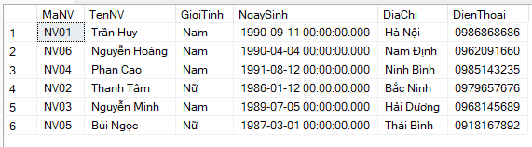

**Bài 4:**

**Code:**

create function h_B4(@ngay datetime)

returns table

as

return (

select *

from tNhanVien

where tNhanVien.NgaySinh = @ngay

);

select * from h_B4('1990-09-11 00:00:00.000');

drop function h_B4;

**Kết quả:**



**Bài 5:**

**Code:**

create function h_B5()

returns table

as

return (

select cthdn.MaSach

from tChiTietHDN cthdn

join tHoaDonNhap hdn

on cthdn.SoHDN = hdn.SoHDN

where cthdn.SLNhap >

(

(

select SUM(hdb1.SLBan)

from (

select tHoaDonBan.NgayBan, tChiTietHDB.SLBan, tChiTietHDB.MaSach

from tHoaDonBan

join tChiTietHDB

on tHoaDonBan.SoHDB = tChiTietHDB.SoHDB

) as hdb1

where cthdn.MaSach = hdb1.MaSach and YEAR(hdb1.NgayBan) = YEAR(hdn.NgayNhap) + 1

)

+

(

select SUM(hdb2.SLBan)

from (

select tHoaDonBan.NgayBan, tChiTietHDB.SLBan, tChiTietHDB.MaSach

from tHoaDonBan

join tChiTietHDB

on tHoaDonBan.SoHDB = tChiTietHDB.SoHDB

) as hdb2

where cthdn.MaSach = hdb2.MaSach and YEAR(hdb2.NgayBan) = YEAR(hdn.NgayNhap) + 2

)

)

);

select * from h_B5();

drop function h_B5;

**Kết quả:**

**Bài 6:**

**Code:**

create function h_B6(@ngay datetime)

returns table

as

return (

select tHoaDonBan.*, (tChiTietHDB.SLBan * tSach.DonGiaBan) as GiaTri

from tHoaDonBan

join tChiTietHDB

on tHoaDonBan.SoHDB = tChiTietHDB.SoHDB

join tSach

on tChiTietHDB.MaSach = tSach.MaSach

where tHoaDonBan.NgayBan = @ngay

);

select * from h_B6('2014-08-11 00:00:00.000');

drop function h_B6;

**Kết quả:**

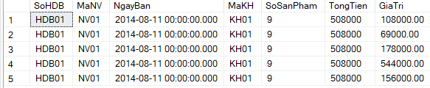

**Bài 7:**

**Code:**

create function h_B7(@nam int)

returns table

as

return(

select MONTH(tHoaDonBan.NgayBan) as Thang, SUM(tChiTietHDB.SLBan * tSach.DonGiaBan) as DoanhThu

from tHoaDonBan

join tChiTietHDB

on tHoaDonBan.SoHDB = tChiTietHDB.SoHDB

join tSach

on tSach.MaSach = tChiTietHDB.MaSach

where YEAR(tHoaDonBan.NgayBan) = @nam

group by rollup(MONTH(tHoaDonBan.NgayBan))

);

select * from h_B7(2014);

drop function h_B7;

**Kết quả:**

**Bài 8:**

**Code:**

create function h_B8(@masach nvarchar(255))

returns int

as

begin

declare @soluong int;

select @soluong = SoLuong

from tSach

where tSach.MaSach = @masach

return @soluong;

end;

declare @returnVal1 int;

set @returnVal1 = dbo.h_B8('S01');

print @returnVal1;

drop function h_B8;

**Kết quả:**

**Bài 9:**

**Code:**

create function h_B9(@matl nvarchar(255))

returns table

as

return(

select tSach.*, dssl.SoLuongNhap, dssl.SoLuongBan

from tSach

join (

select tSach.MaSach, SUM(tChiTietHDN.SLNhap) as SoLuongNhap, SUM(tChiTietHDB.SLBan) as SoLuongBan

from tSach

join tChiTietHDN

on tSach.MaSach = tChiTietHDN.MaSach

join tChiTietHDB

on tSach.MaSach = tChiTietHDB.MaSach

where tSach.MaTheLoai = @matl

group by tSach.MaSach

) as dssl

on dssl.MaSach = tSach.MaSach

);

select * from h_B9('TL01');

drop function h_B9;

**Kết quả:**

